

**AMERICAN INTERNATIONAL UNIVERSITY–BANGLADESH (AIUB)**

**FACULTY OF SCIENCE & TECHNOLOGY**

**DEPARTMENT OF PHYSICS**

**PHYSICS LAB 2**

**Summer 2020-2021**

**Section: X, Group: 07**

**LAB REPORT ON**

***To determine the frequency of electrically maintained tuning fork by means of Melde’s apparatus in transverse mode of vibration***

**Supervised By**

**Dr. Md. Nurul Kabir Bhuiyan**

**Submitted By**

|  |  |  |
| --- | --- | --- |
| **Name** | **ID** | **Contribution** |
| **1. Md. Fahtin Emtiaz Onik** | **19-40471-1** | **Introduction, Discussion** |
| **2. Nafinur Leo** | **20-42195-1** | **Apparatus, Procedure** |
| **3. S.M, Ashikur Rahman** | **20-42833-1** | **Experimental Data Table** |
| **4. S.M. Hosney Arafat Rizon** | **20-43019-1** | **Result, Analysis** |
| **5. Rad Shahmat Sabit** | **20-43610-1** | **Calculation, References** |

Date of Submission: **August 01, 2021TABLE OF CONTENTS**

|  |  |
| --- | --- |
| **TOPICS** | ***Page no*.** |
| **i) Title Page** | 1 |
| **ii) Table of Content** | 2 |
| 1. **Introduction** | 3 |
| 1. **Apparatus** | 4 |
| 1. **Procedure** | 4 |
| 1. **Experimental Data** | 5 |
| 1. **Analysis and Calculation** | 6 |
| 1. **Result** | 6 |
| 1. **Discussion** 2. **References** | 6  7 |
|  |  |
|  |  |

**1. Introduction**

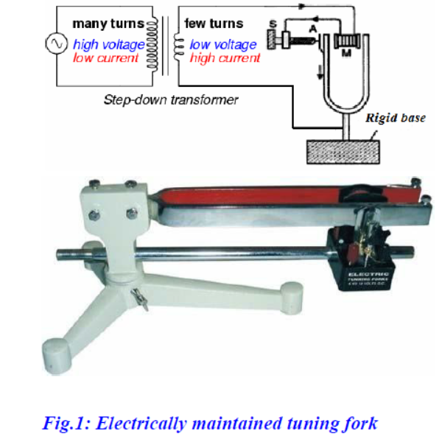

**Transverse mode of vibration:**

The frequency of electrically maintained tuning fork in transverse mode of vibration is determined by following formula.

$$n= \frac{P}{2l}\sqrt{\frac{Mg}{m}} (1)$$

Where l = loop length of the thread

T = tension applied to the wire=Mg

M= total mass loaded on thread

m = mass per unit length of the thread

**Figure & Circuit:**

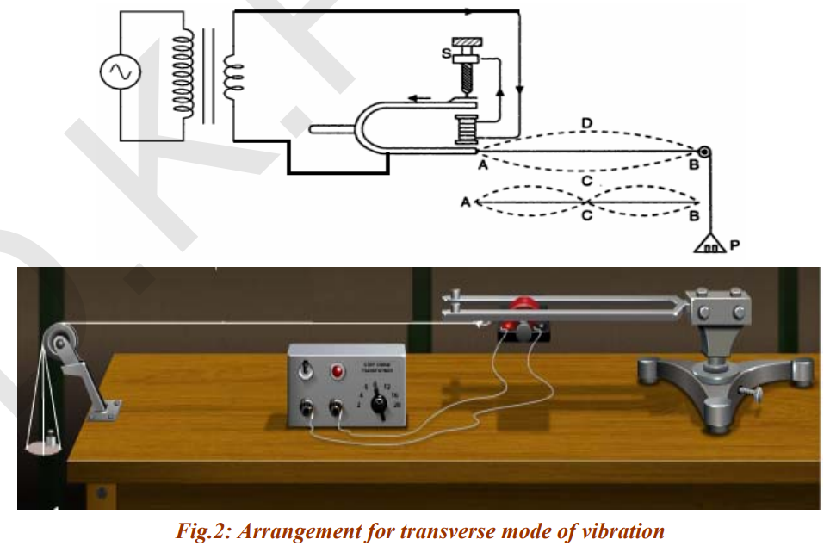

**2. Apparatus**

(1) Electrically maintained tuning fork

(2) Hanger/pan

(3) Weights (5, 10, 20 gm)

(4) Thread

**3. Procedure**

(1) The primary of the step down transformer was connected to A.C mains, while the secondary to the given point of electrically maintained tuning fork.

(2) Then the one end of thread was tight to the prong of tuning fork and other end to a scale pan. By hanging the scale pan with pulley that was fixed at end of table.

(3) After that, the electrically maintained tuning fork was arranged in transverse situation (Fig.2) (i.e. arrange in such a way that length of string was parallel to the prong of tuning fork) and load a mass of 5gm on its pan. The screw S was rotate (i.e. excite the tuning fork), so that vibration in tuning fork started.

(4) The tuning fork was move toward or away from pulley to adjust the length of thread, so that loops could be formed. The length thread for one and two loop was measured when stable loops were formed in horizontal plane, as a result it was given the value l for one and two loops.

(5) The mass was increased on scale pan (m=10, 20 gm) and repeated the step 4.

(6) More specifically it was arranged in such a way that length of string was perpendicular to the prong of tuning fork. Then a mass of 5gm was load on its pan. It was seen that vibrations was started in tuning fork.

(7) Then the tuning fork was move toward or away from pulley to adjust the length of thread, so that loops could be formed. The length thread for one and two loop was measured when stable loops were formed in horizontal plane, as a result it was given the value l for one and two loops.

(8) Again the mass was increased on scale pan (m=10, 20 gm) and repeated the step 7 for this arrangement.

(9) After that, the length of thread per loop l/p for each case of load was found out.

(10) The mass (mt) of 10m length of thread and mass of scale pan (mp) was measured. Value of mt/10 was given mass per unit length of thread.

(11) Finally the mean frequency of electrically maintained tuning fork was calculated.

**4. Experimental Data**

(A) Mass of the scale pan, w = 23.4 gm

(B) Length of the sample thread, L = 204 cm

Mass of the thread, M = 0.8 gm  
Mass per unit length of the thread, $m= \frac{M}{L}= \frac{0.8}{204}=3.92×{10}^{-3}$ gm/cm

**Table 1: Transverse position**

|  |  |  |  |  |  |  |  |  |  |
| --- | --- | --- | --- | --- | --- | --- | --- | --- | --- |
| **No. of observation** | **Total no of loops between the fixed ends** | **Load on the scale pan (Wt) gm** | **Tension T = Wg = (W+Wt)g dynes** | **Distance between the pins (G)** | **No. of loops between the pins (N)** | **Length of a segment $$l= \frac{G}{N}$$** | $$\frac{T}{l^{2}}=$$ $$const$$ | **Frequency of the string n’ = $$\sqrt{ (\frac{1}{m}×\frac{T}{4l^{2}})}$$** | **Frequency of the n = n’** |
| 1 | 5 | 0 | 23932 | 116 | 5 | 23.2 | 42.6 | 52.123 | 52.123 |
| 2 | 4 | 5 | 27832 | 98.5 | 4 | 24.63 | 45.8 | 54.093 | 54.093 |
| 3 | 3 | 10 | 32732 | 80 | 3 | 26.67 | 46.02 | 54.175 | 54.175 |
| 4 | 2 | 15 | 37632 | 63 | 2 | 31.5 | 37.93 | 49.183 | 49.183 |

**5. Analysis and Calculation**

$$n=\frac{52.123+54.093+54.175+49.183}{4}$$

$$= \frac{209.574}{4}=59.39 Hz$$

Percentage of error = $\frac{nth-nex}{nth} *100$

= $\frac{50-59.39}{50} *100$

= 0.1878 * 100

= 18.78%

**6. Result**

Mean frequency of electrically maintained tuning fork = 59.39 Hz

Percentage of error 18.78%

**7. Discussion**

The purpose of the experiment is to determine the frequency of electrically maintained tuning fork by means of Melde’s apparatus in transverse mode of vibration. The value of frequency is 44.144 Hz

(1) Value of frequency was 59.39 Hz and theoretical value was 50 Hz

(2) Percentage of error 18.78%

(3) The thread was ensured uniform and inextensible.

(4) It was frictionless otherwise it made the tension to be less than the actual applied tension.

(5) The loops in central part of the thread were counted for measurement.

(6) The nodes were neglected at pulley and tip of prong as it had some motion.

**8. References**

*(i) Fundamental of physics: Resnick & Halliday*

*(ii) Practical physics: R. K. Shukla, Anchal Srivastava, New Age International (p) ltd,New Delhi*

*(iii) Zemansky, M.W. (1968) Heat and Thermodynamics*